**Social Media Safety and Awareness:**

**Team-21-22_044**

**The Mission:**

We done a project based on Student social responsibility concept in which our moto is to share our knowledge to society which is useful.

Based on our moto we held many discussions with our project councillor and finally we take-up the concept “Social Media Awareness and Cyber-Security”.

This is the project we have to teach about social media safety and awareness and cybercrime and have to add more functionalities as it deserved, where it may useful to people who don’t aware of the medias they are using.

Hence it is a virtual programming we try to make everything in online, using different platforms for work purpose.

>> Project Idea was accepted in 2nd meeting with respective councillor.

>> Initial Presentation is completed.

**Core Contributors:**

Honest Efforts were put by every one into the project where we special thanks to Kiran sir our SSR head, Ms. Indira mam our project Mentor and our Webinar speaker Mr. Harish Reddy from Ness digital solutions.

Bachina Abhinay who is Our team leader who can able to balance all issues and set up good environment to make the project in a way.

Bhargav and Jagadeesh contributors in PPT presentations and maintaining data.

Gnaneswar and Bharath are well in their part of handling feedbacks Quizs Document distributions.

Phani and Subha Reddy are helpful in Webinar gathering crowd, making necessary arrangements to webinar speaker.

**Activities undertaken:**

After the Project was finalized, we had achieved our plans as we discussed earlier so for that we made plans accordingly.

We split up Execution in a phase’s:

**🡪Phase-1:**

As a phase 1 we make a documentation and publish as a short Booklets that may help to know about our moto and it’s been as a promotion to our Webinar in a phase-2.

**Setbacks:**

>>A way how to design a Document and things insert inside.

>>Targets

**Achievements:**

>>As we planned, we make up document in a self-made process with the help of team leaders.

>>Successfully published into crowd.

**🡪Phase-2:**

As a phase one we are ready to conduct a webinar by inviting a speaker from outside, as a professional/as a person who may aware of this type of things ex: Software developer, Police Department etc.

As planned all our webinar is end up successfully.

>> we keep recording as a proof

>> we use more platforms for promotions and invitations ex: Instagram (Ulapathi), Whats App, visiting nearby schools etc.

>> Held Webinar online, platform based on Google-Meet.

**🡪Phase-3:**

As a we planned, we have to complete webinar and Quizs on or before phase-2 when it comes to phase-3 we have to make ready final ppt, final Document, Blog and video recordings along with feedback forms and Quizs statistics everything as a document to submit as a final work.

**Achievements:**

>> We completed Final PPT and Document.

**Setbacks:**

Many modifications in between preparation of doc and ppt.

**Background of the Problem:**

Main problem is that Student’s in village level institutions have communication problem, so we try to make documents and recordings and webinars accordingly by their kind understand way. As a student’s this is our responsibility to participating in type of Programs (SSR) and we prefer to do this.

we discussed possible ways to implement this project, it mainly targets below 20 years aged students.

>> Meetings with mentor and many references we came up with an idea to make webinar with professional speaker, since it is a Virtual program.

1. This gives awareness about Terms & Conditions
2. Published Document Provides information about safety and Security along with webinar details.
3. Webinar includes cyber security, Safety, Security, Privacy and uses in social media.

**Images:**

**Team members**:

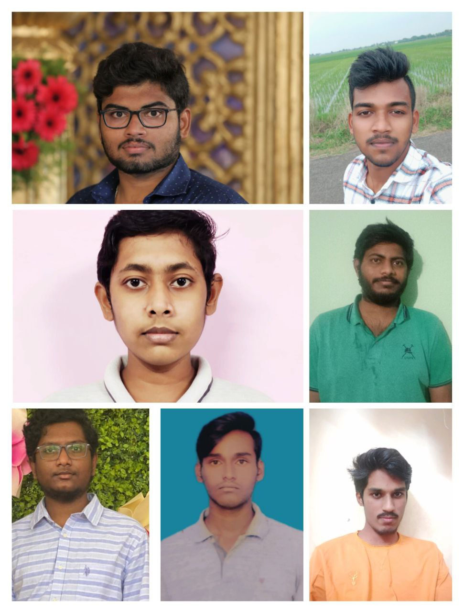

**Phase-1:** Document distribution to Individuals.

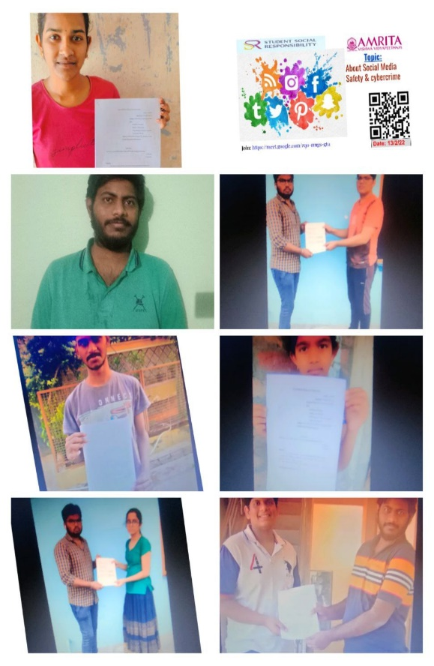

**Speaker:** Mr. Harish kumar Reddy , who is a senior tech lead in ness technologies.

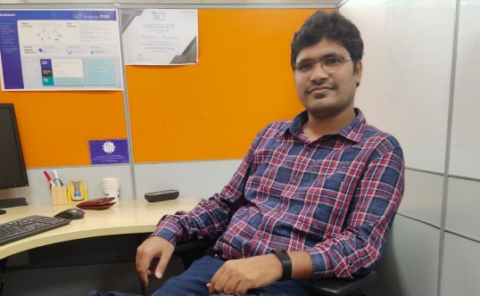

**Obstacles Faced:**

>> Since it is Online, setting up groups and projects was difficulty.

>> Inadequate skills among us may result delay in accurate submissions.

>> Lack Of communication.

>> Continuing Project in Virtual mode is difficulty.

**Total Man Hours:**

Since from December 2021

**Planning:**

5-6hrs

**Preparation:**

8hrs

**Execution:**

19-20hrs

**Road Ahead:**

After completion of the project, our team was so satisfied that we agreed upon doing such social activities sooner or later. We also like to spread this awareness and the knowledge we got, to other Students and hence bring that vital change required in the societies.

We support social responsibility programs and suggest to all.

**Roses and Thorns:**

>> Getting Involved in projects like SSR is very good sign for us in future projects.

>> Interaction with juniors through online mode is good experience

<<< Inadequate skills among group members are some hard to conclude project.

<<< Programs like SSR through online is less benefit.

**Conclusion:**

We Thank to Amrita, welcoming us to participate in responsible Projects like SSR.

We supposed to thank our Mentors, CIR department, Our speaker Mr. Harish Reddy.

**\*\*THANK YOU\*\***